SIMATS ENGINEERING
Co3-ASSESSMENT TOOL 2

Case study

COURSE NAME: Computer Networks COURSE CODE: CSA0706

COURSE OUTCOME COVERED

CO3: Analyze the performance of core network protocols such as TCP, UDP, HTTP, and DNS under varying conditions

Assessment Tool Weightage: 40% Dr.V.Parthipan
QUESTIONS:4 Total Marks:40

Code of Conduct:

I RUCHITA.S (192572081) certify that this submission is my original work and that I have adhered to the guidelines specified for this assessment. I understand that any violation of academic integrity rules will result in disciplinary action.

Signature of the student:

RUCHITA.S

Criteria | Understanding the case  2.5 | Application of Concepts 2.5 | Analysis  2 | Solution Design 2 | Clarity  1 | Total (10)
Q1
Q2
Q3
Q4

Faculty Signature

QUESTIONS:4 Total Marks:40

- A multinational IT company uses a cloud-based video conferencing platform for daily client meetings. During peak business hours, employees experience frequent voice distortion, frozen video frames, and delayed communication. Network monitoring reports indicate an 8% packet loss, 180 ms jitter, and fluctuating bandwidth utilization. The IT administrator suspects that the issue is related to the transport protocol or application-level buffering strategy.

  - Analyze whether the problem is primarily caused by the transport protocol (TCP/UDP) or the application layer.

SOLUTION:
The problem is primarily related to the transport protocol and network conditions, with application-level buffering also contributing.
Real-time video conferencing generally requires UDP-based transport because UDP does not wait for retransmission of lost packets. With 8% packet loss and 180 ms jitter, packets are either being lost or arriving at irregular times. This directly causes:
- Voice distortion
- Frozen video frames
- Delayed audio/video
- Poor synchronization
If TCP were used for real-time media, its retransmission and congestion-control mechanisms could introduce additional delay because TCP waits for lost packets to be retransmitted.
Therefore, the high packet loss, jitter, and fluctuating bandwidth are the primary causes, while the application's buffering strategy determines how effectively it handles these network problem
  - Justify your answer based on the communication requirements of real-time multimedia applications.

SOLUTION:
Real-time multimedia prioritizes low delay over perfect delivery.
Feature | TCP | UDP
Connection | Connection-oriented | Connectionless
Retransmission | Yes | No
Ordering | Guaranteed | Not guaranteed
Delay | Higher | Lower
Real-time audio/video | Less suitable | More suitable
For a video conference, receiving a video packet 200 ms late may be almost as bad as losing it. Therefore, retransmitting every lost packet is not always useful.
UDP allows the application to continue receiving current packets instead of waiting for old packets.
  - Recommend suitable protocol-level or application-level improvements to enhance conferencing quality.

SOLUTION:
Protocol-level improvements:
- Use UDP for real-time audio/video traffic.
- Apply congestion control suitable for real-time media.
- Prioritize voice/video packets using QoS.
- Reduce packet loss through better network capacity and routing.
- Use adaptive bitrate mechanisms when bandwidth decreases.
Application-level improvements:
- Use an adaptive jitter buffer.
- Dynamically reduce video resolution/bitrate when bandwidth drops.
- Use packet-loss concealment for missing audio/video data.
- Prefer newer frames over delayed retransmitted frames.
- Monitor bandwidth and automatically adjust media quality.
- A multinational software company hosts its web services across multiple continents. Employees frequently report long delays before the application homepage loads. Network analysis shows that the average DNS lookup time is approximately 800 ms, significantly affecting user experience. The organization plans to redesign its DNS infrastructure while ensuring continuous service availability during server failures.
Questions
  - Analyze the reasons behind the high DNS resolution time.

SOLUTION:
Reasons for high DNS resolution time
- Long resolution chain: recursive queries traveling from local resolver → root → TLD → authoritative server, each hop adding round-trip latency, especially if servers are geographically distant.
- Low cache hit rate: if TTL values are too short, records expire frequently, forcing repeated full lookups instead of using cached results.
- Single/centralized authoritative server: if all clients worldwide query one server location, users far from that server experience high latency.
- No geographic routing: without Anycast, all queries go to the same physical server regardless of client location.
- Overloaded DNS servers: high query volume without load distribution causes queuing delay.
- No pre-fetching: browsers/apps not resolving likely-needed domains in advance
  - Propose a suitable DNS architecture using techniques such as Anycast DNS, DNS pre-fetching, and TTL optimization to reduce the lookup time below 50 ms.

SOLUTION:
A suitable architecture is:
User → Local DNS Resolver → Anycast DNS → Nearest DNS Server → Cached/Authoritative Response

Step 1: Anycast DNS
Deploy DNS servers at multiple geographical locations using Anycast routing.
The same DNS IP address is announced from multiple locations. Routing directs users toward a nearby DNS server.
Benefit: Reduces geographical latency and distributes traffic.

Step 2: DNS caching
Resolvers should cache frequently requested DNS records.
For example:
First request → DNS lookup → Store result in cache
Next request → Cache → Immediate response
This avoids repeated complete DNS resolution.

Step 3: DNS pre-fetching
Frequently accessed domain records can be refreshed before they expire.
This ensures that cached records remain available without forcing users to wait for a fresh lookup.

Step 4: TTL optimization
TTL should be selected carefully.
- Very short TTL → frequent DNS queries
- Very long TTL → stale records may remain in caches
A balanced TTL reduces DNS traffic while maintaining reasonably fresh records.

  - Evaluate the advantages and limitations of your proposed architecture in terms of performance, scalability, and availability.

SOLUTION:
Feature | Advantage | Limitation
Anycast DNS | Low latency | More infrastructure required
Caching | Very fast repeated queries | Cached data can become stale
Pre-fetching | Reduces lookup delays | Generates additional DNS traffic
TTL optimization | Balances freshness and performance | Requires careful configuration
Multiple DNS servers | High availability | Higher operational complexity

EXPECTED RESULT:
The proposed architecture should significantly reduce DNS lookup latency. With geographically distributed Anycast servers and effective caching, the organization can target less than 50 ms for typical DNS lookups, as required by the case.
3.A cloud service provider delivers applications to millions of users worldwide. During promotional events, users experience intermittent delays in accessing cloud-hosted services. Investigation reveals that DNS queries are taking nearly 800 ms because all requests are directed to a single primary DNS server. The company wants a highly available DNS solution capable of handling global traffic efficiently.

Questions

- Examine the impact of centralized DNS architecture on application performance.

SOLUTION:
The centralized architecture can be represented as:
Millions of users → One DNS Server → IP Address
This creates a single point of failure and performance bottleneck.
The main impacts are:
- High latency because every request travels to the same server.
- Server overload during promotional events.
- Increased DNS response time.
- Poor application startup/loading performance.
- If the server fails, DNS resolution may become unavailable.
- Scalability becomes difficult because traffic continuously increases.
The 800 ms DNS delay directly increases the time required to access cloud application
- Design a distributed DNS solution that minimizes lookup latency while maintaining high availability.

SOLUTION:
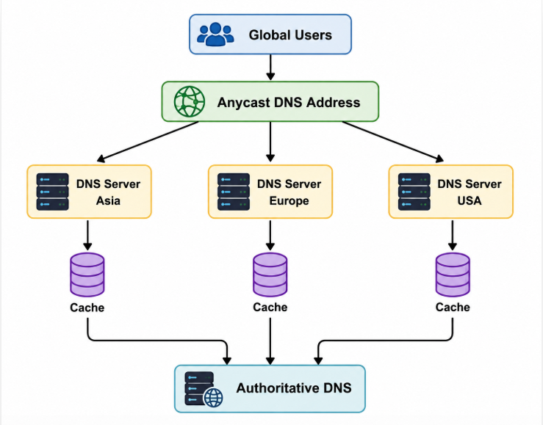
WORKING:
Step 1: Deploy DNS servers in multiple geographical regions.
Step 2: Use Anycast routing so users are directed to an appropriate nearby DNS server.
Step 3: Enable DNS caching at recursive resolvers.
Step 4: Use appropriate TTL values so cached records remain available.
Step 5: Maintain multiple authoritative DNS servers for redundancy.
Step 6: If one DNS server fails, traffic can be routed to another available server.
- Analyze how TTL values, Anycast routing, and DNS caching influence system performance and fault tolerance.
SOLUTION:
TTL
TTL determines how long a DNS response can remain in a cache.
- Appropriate TTL → fewer DNS queries
- Excessively short TTL → more DNS traffic
- Excessively long TTL → potentially stale information
Anycast
Anycast allows multiple DNS servers to use the same service address.
Effect:
User → nearest available DNS server → faster response
It also improves fault tolerance because traffic can be routed to another location when one server becomes unavailable.
DNS caching
Caching stores DNS responses closer to users.
For repeated requests:
Without cache:
User → Resolver → DNS infrastructure → Response
With cache:
User → Cached response
Therefore, caching greatly reduces lookup time and DNS infrastructure load.
4.A financial institution operates an electronic stock trading platform where thousands of buy and sell orders are submitted every second. During market opening hours, the average order acknowledgment latency increases from 1 ms to 40 ms, resulting in delayed trade confirmations and customer dissatisfaction. Network engineers observe increased TCP retransmissions, longer connection establishment times, and excessive buffering.
Questions

- Analyze three possible TCP-related factors responsible for the latency increase, considering flow control, Nagle's algorithm, and SYN queue limitations.

SOLUTION:

A. TCP Flow Control
TCP uses a receive window to control how much data can be sent before acknowledgment.
If the receiver's buffer becomes full, the advertised window becomes smaller.
This causes the sender to slow down.
Effect:
High traffic
↓
Receiver buffer fills
↓
Receive window decreases
↓
Sender slows down
↓
Order processing becomes delayed
For a high-frequency trading system, even small delays can affect transaction processing.

B. Nagle's Algorithm
Nagle's algorithm combines small TCP packets into larger packets to reduce network overhead.
This is useful for normal applications, but it can be harmful for small, latency-sensitive trading messages.
For example:
Small order message
↓
Nagle waits for ACK / more data
↓
Packet transmission delayed
↓
Order acknowledgment delayed
Therefore, Nagle's algorithm can introduce unnecessary latency in high-frequency transactions.

C. SYN Queue Limitations
TCP establishes a connection using the three-way handshake:
Client Server

SYN -------------------->
<---------------- SYN-ACK
ACK -------------------->
During market opening, thousands of connection requests may arrive simultaneously.
If the server's SYN queue becomes full, new connection requests may be delayed or dropped.
This results in:
- Longer connection establishment
- Retransmitted SYN packets
- Increased latency
- Possible connection failures
- Explain how each factor affects transaction processing in high-frequency systems

SOLUTION:

TCP factor | Effect on trading
Flow control | Limits transmission when receiver buffers are congested
Nagle's algorithm | Can delay small order messages
SYN queue limitations | Delays new TCP connections
Retransmissions | Increase processing time
Excessive buffering | Creates additional queueing delay
Since financial trading requires extremely low latency, these delays can cause orders and confirmations to arrive later than expected.
- Recommend appropriate TCP configuration changes to reduce latency and improve transaction reliability.

SOLUTION:

1. Disable Nagle's algorithm
Use TCP_NODELAY for latency-sensitive trading connections. This allows small messages to be transmitted immediately rather than waiting to combine them.

2. Optimize TCP receive/send buffers
Configure appropriate TCP buffer sizes so that the system can handle high transaction rates without excessive buffering.

3. Increase SYN queue capacity
Increase the server's SYN backlog/queue capacity to handle large numbers of simultaneous connection requests.

4. Reduce unnecessary connection establishment
Where appropriate, use persistent TCP connections rather than repeatedly establishing new connections.

5. Monitor retransmissions
Identify packet loss and network congestion causing TCP retransmissions.

6. Use QoS and network optimization
Prioritize latency-sensitive trading traffic and minimize congestion along the network path.

RUBRICS FOR CALCULATION:

Criteria | Weightag e | Level 4 – Exemplary | Level 3 – Proficient | Level 2 – Developing | Level 1 – Beginning
Understandin g of Case | 25 | Thorough understandin g; clearly identifies all key issues | Good understandin g with most issues identified | Basic understandin g; some issues missed | Poor understandin g; problem not identified correctly
Application of Concepts | 25 | Effectively applies relevant concepts to analyze the case deeply | Applies appropriate concepts with minor gaps | Limited application of concepts | Fails to apply relevant concepts
Analysis | 20 | In-depth analysis with strong reasoning and insights | Good analysis with logical reasoning | Basic analysis with limited depth | Weak or no analysis; lacks reasoning
Solution Design | 20 | Innovative, feasible solutions with strong justification | Logical solutions with adequate justification | Basic solutions with weak justification | Incorrect or no solution provided
Clarity | 10 | Clear, well-structured, and easy to understand | Organized and understandab le presentation | Limited clarity and structure | Poor clarity; difficult to understand

